FEATURES BY RUBRICS:

|  |  |
| --- | --- |
| **I. User** | |
| Browse items without registering (/2) | ✓ |
| Responsive design philosophy (minimum requirements for different non-mobile display sizes (/2) | ✓ |
| Server-side security and validation - best practices for password handling (/2) | ✓ |
| Search for items/posts by keyword without registering (/2) | ✓ |
| Item and associated details stored in the database (/2) | ✓ |
| Form validation with JavaScript (/2) | ✓ |
| Register at the site by providing their name, e-mail and image (/4) | ✓ |
| Allow user login by providing user id and password (/2) | ✓ |
| Create and comment on (specific for each project) when logged into the site (/2) | ✓ |
| Users are required to be able to view/edit their profile (/2) | ✓ |
| User password recovery (via email) (/4) |  |
| Error handling/bad navigation (/2) | ✓ |
| Site must maintain state (user state being logged on, Shopping cart is persistent between sessions (/4) | ✓ |
| **II. Website administrator’s objectives:** | |
| Search for user by name, email or post ( /2) | ✓ |
| Enable/disable users (/2) | ✓ |
| Edit/remove items and comments (you must be able to add items to the store, along with images of the items as well as setting the required information) (/4) | ✓ |

|  |  |
| --- | --- |
| **III. Additional Features:** |  |
| Activity by date (/3) | ✓ |

WEBSITE FEATURES/WALKTHROUGH :

HOME PAGE:

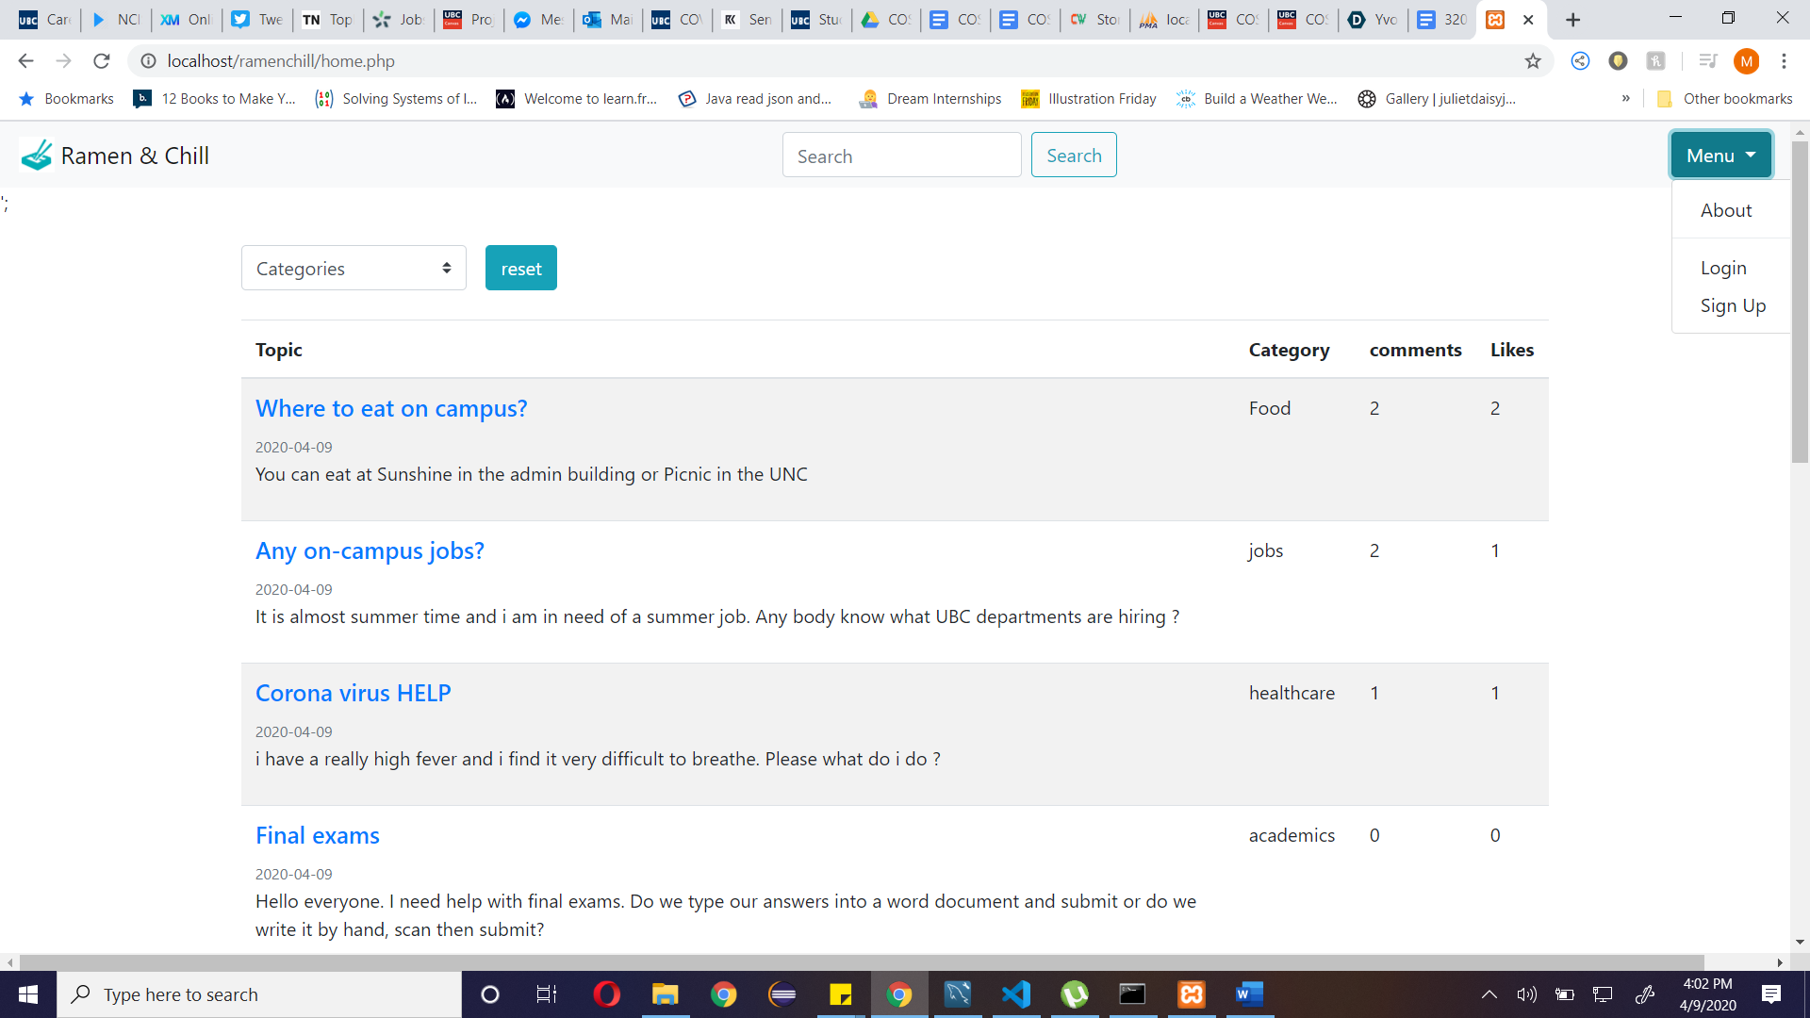

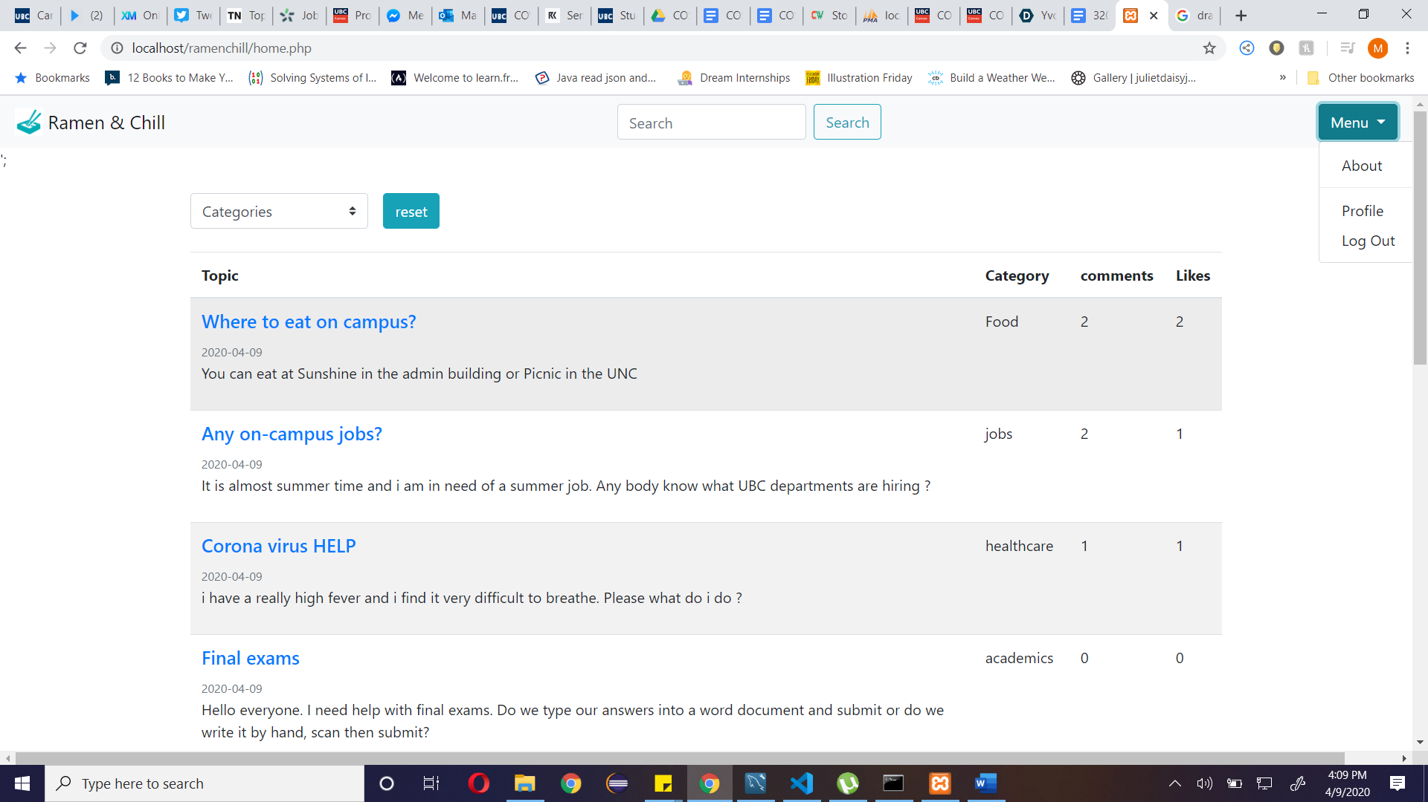

FEATURES (before user log on):

* Search bar: both registered and unregistered users can search for forum posts
* Categories filter: both registered and unregistered users can filter forum posts by category
* Menu: unregistered users have access to the about page, login and signup pages.

FEATURES (after user log on):

* Menu: registered users have access to the about page, profile page and the logout option

SIGN UP PAGE:

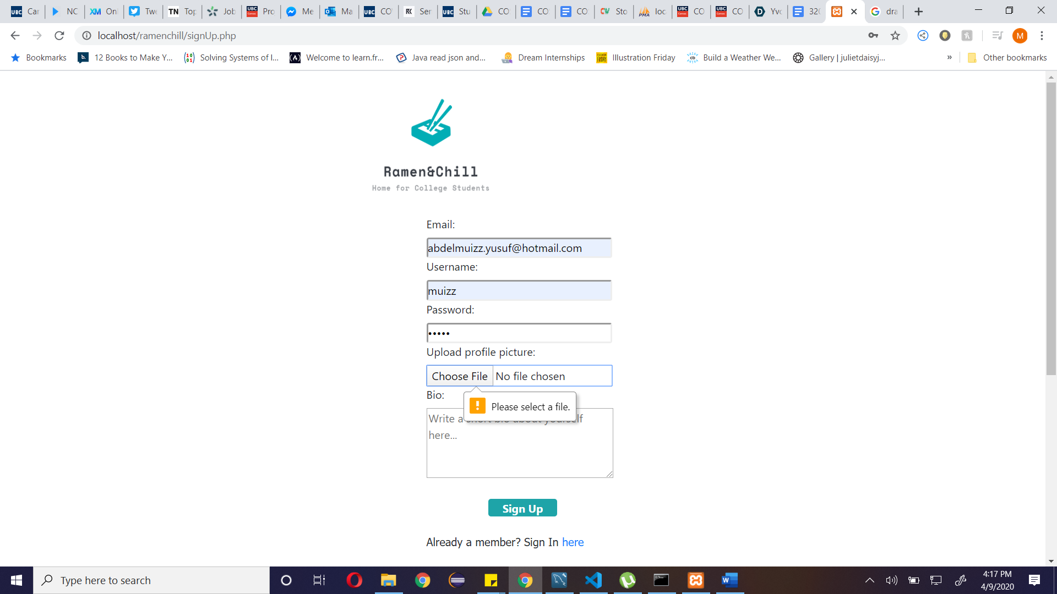

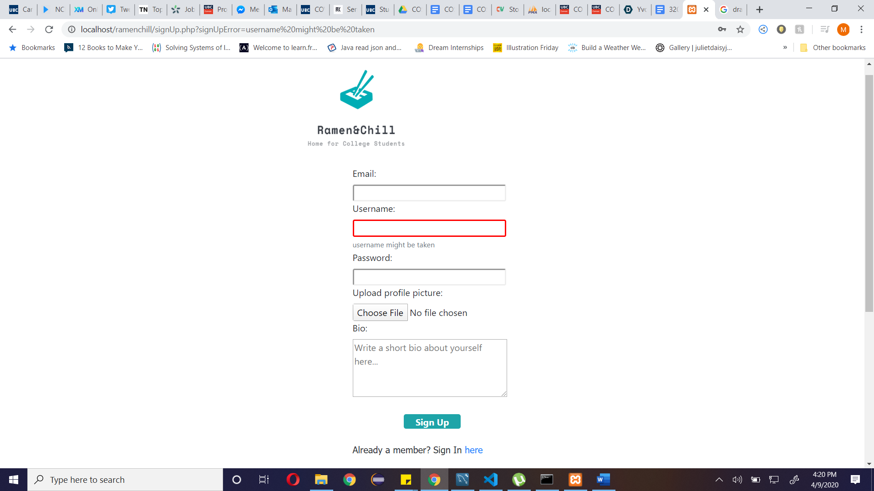

FEATURES:

* Logo: on-click, returns to home page.
* Sign up form containing required fields of email, username, password, profile picture and bio.
* If username already exists, form indicates error upon submission.
* Sign in link at the bottom of the form, linking to the sign in page.

LOG IN PAGE:

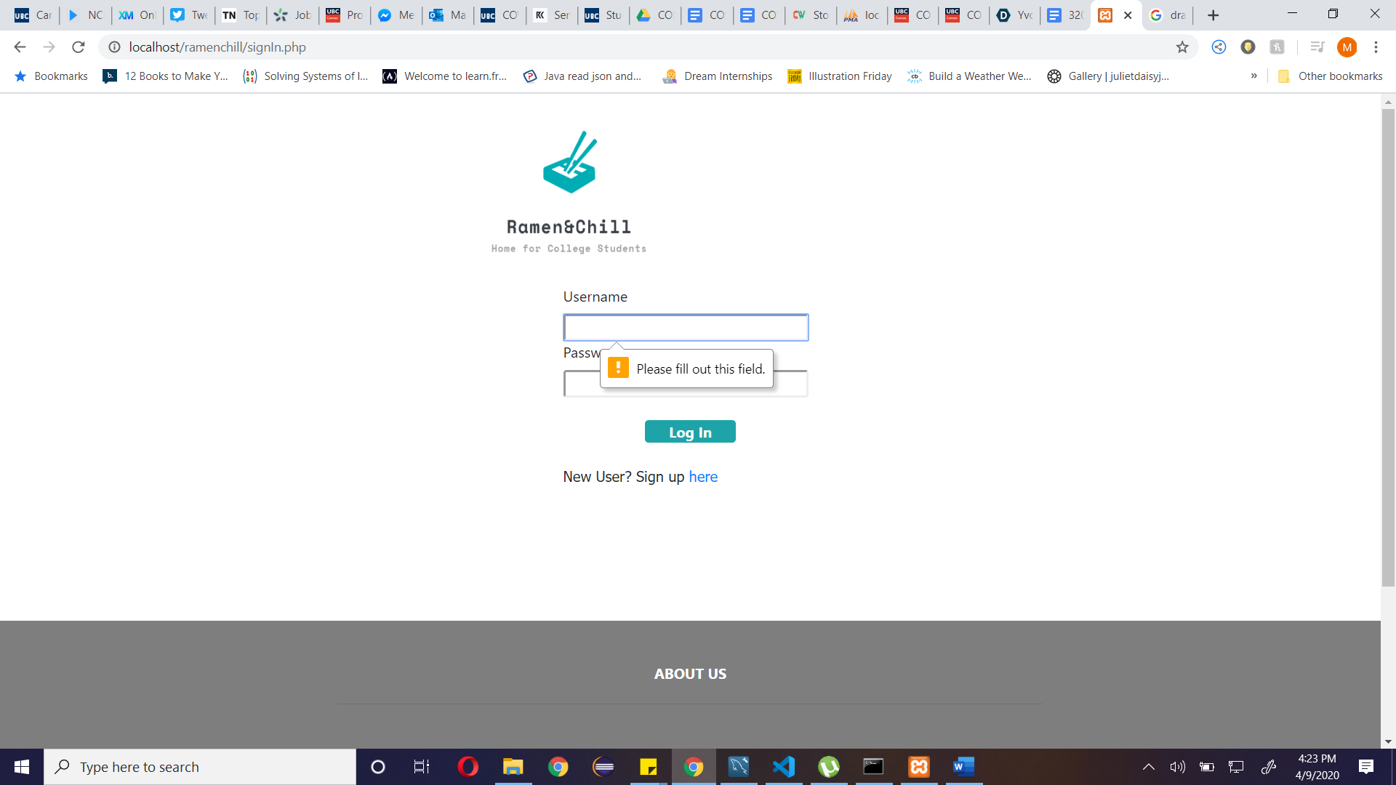

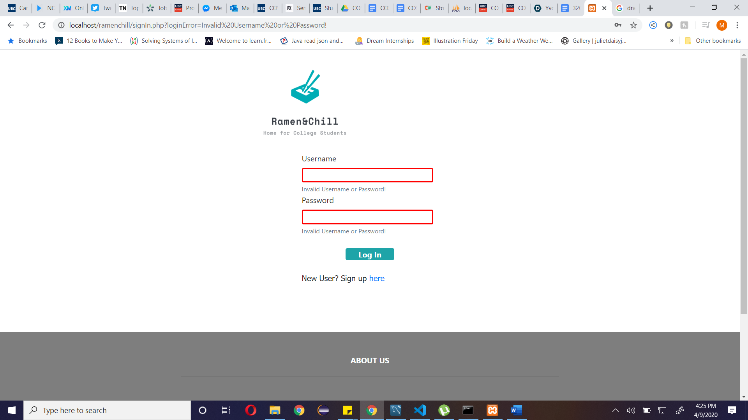

FEATURES:

* Logo: on-click, returns to home page.
* Sign in form containing required fields of username and password.
* If wrong username or password is entered, form indicates error upon submission.
* Sign up link at the bottom of the form, linking to the sign-up page.

PROFILE PAGE:

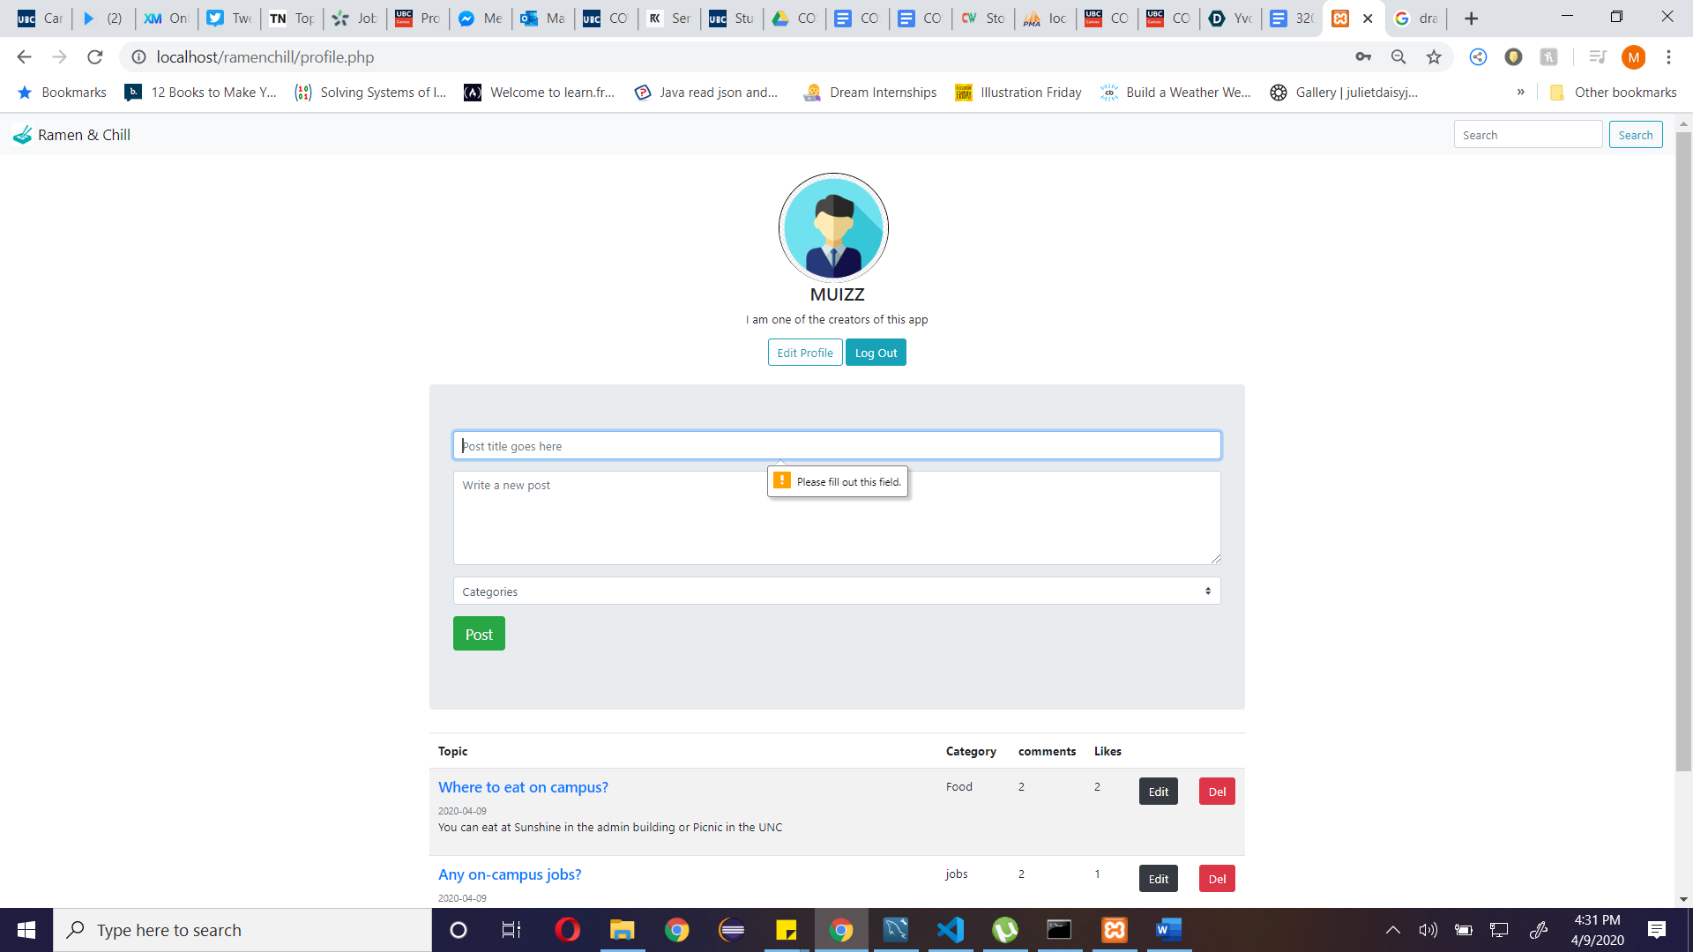

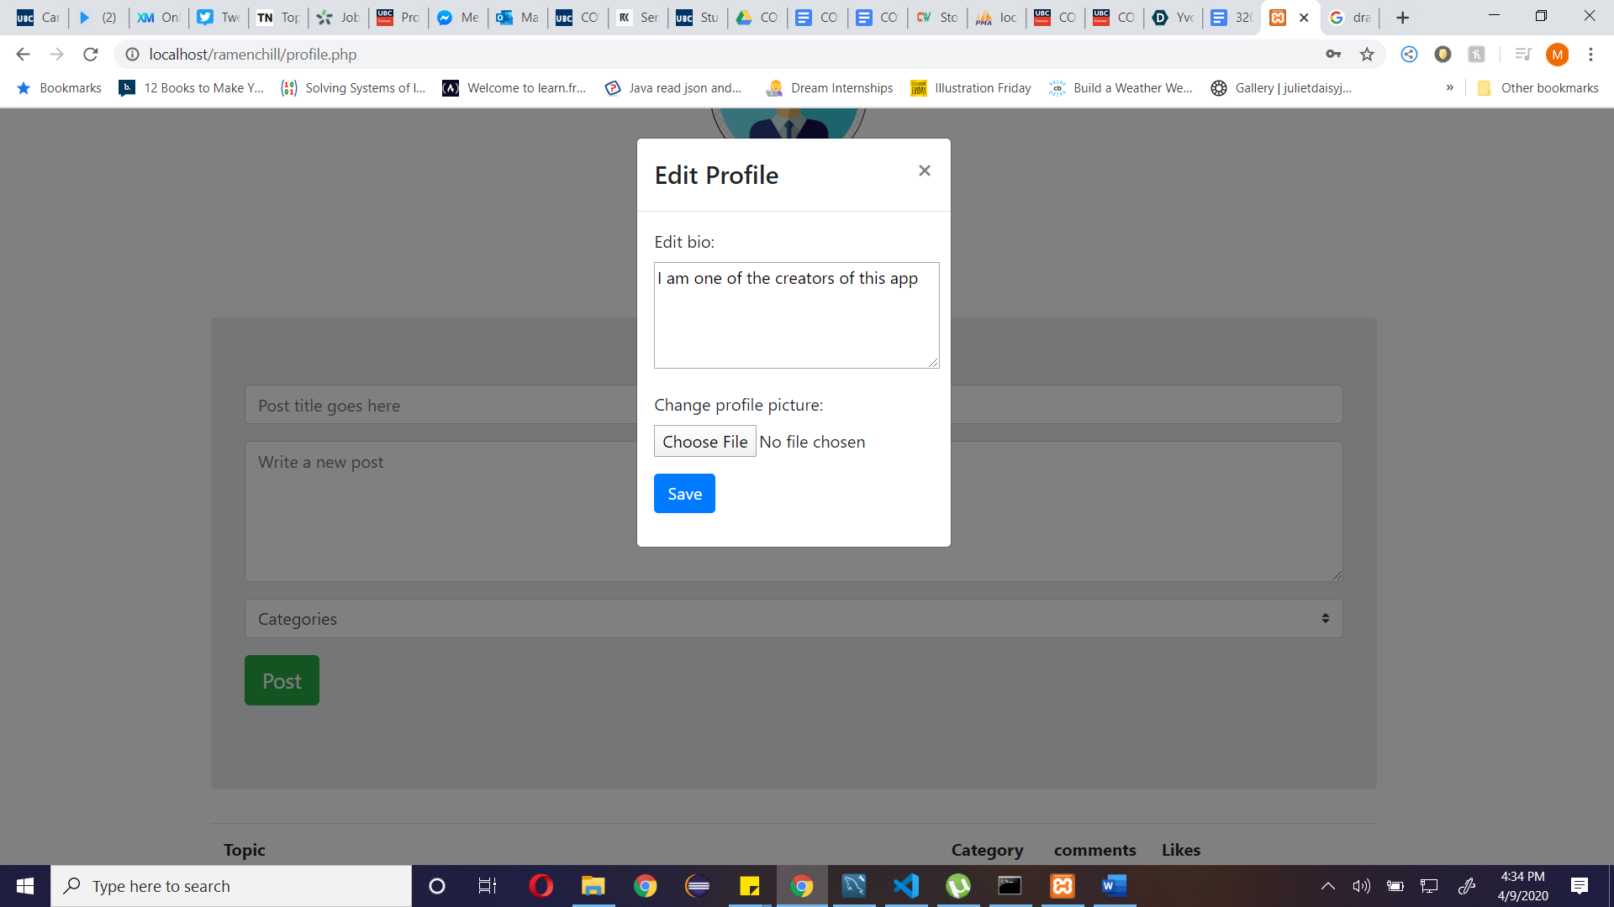

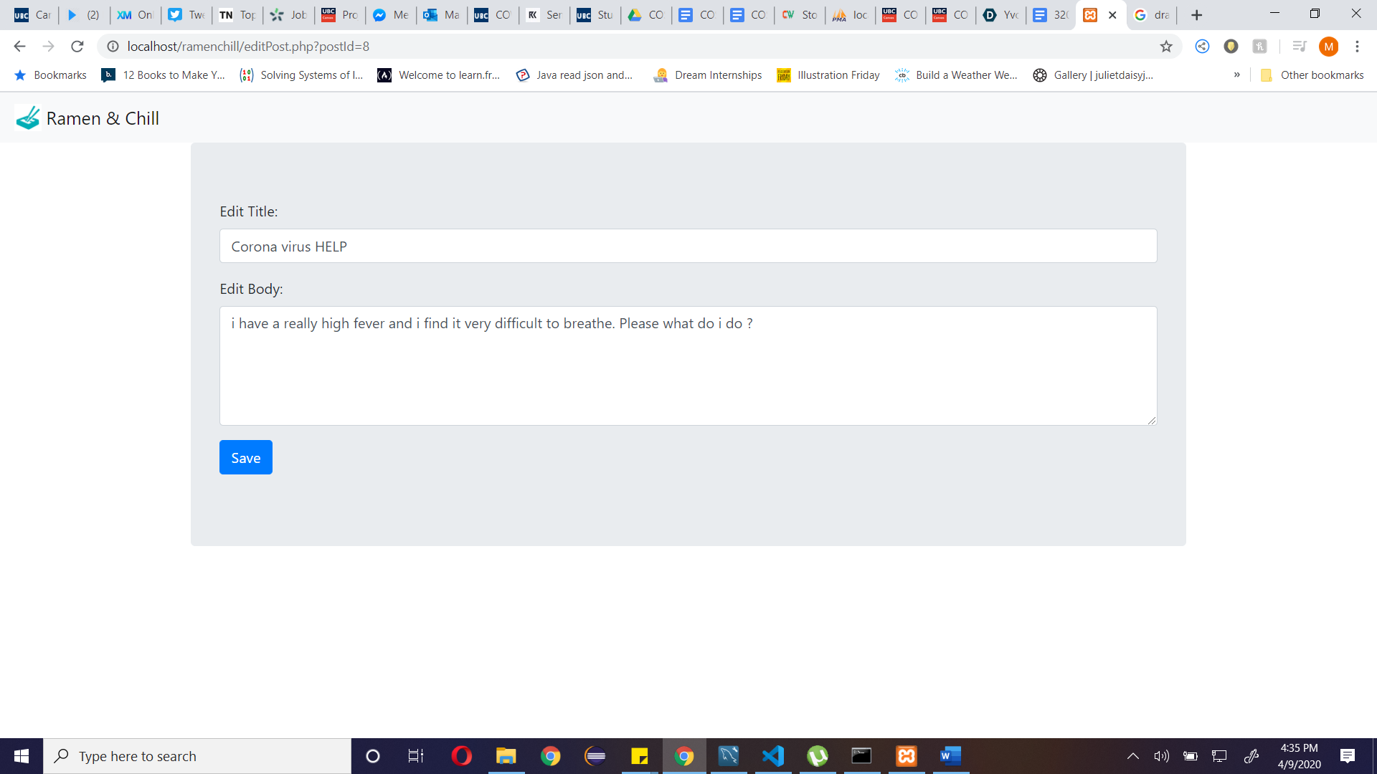

FEATURES (only available to registered users):

* Profile head: displays profile picture, username, user bio, edit profile and log out buttons.
* Navbar: on click of logo returns user to home page and search bar to search all posts.
* Post section: contains form with all required fields which users can use to make a post upon submission.
* User posts section: list of user posts and its details. Each post title links to individual post page. Also contains edit post button and delete post button.

POST PAGE:

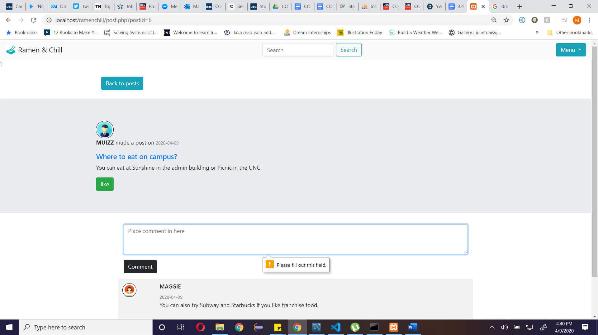

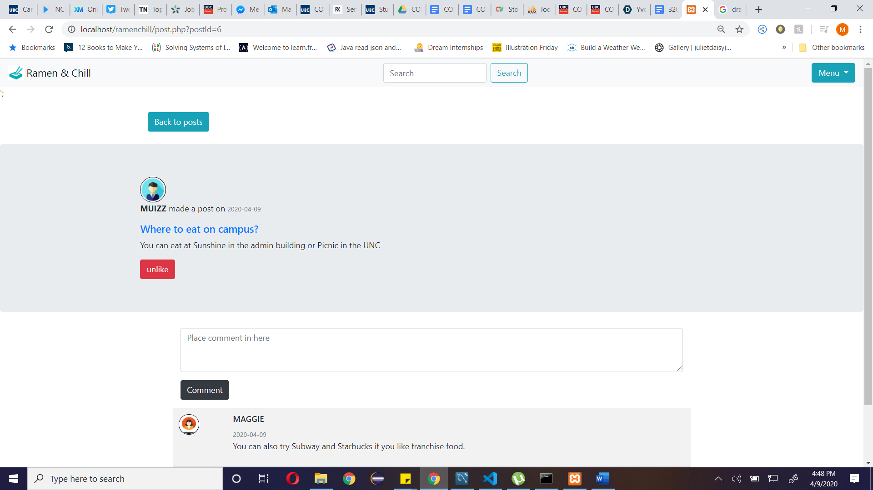

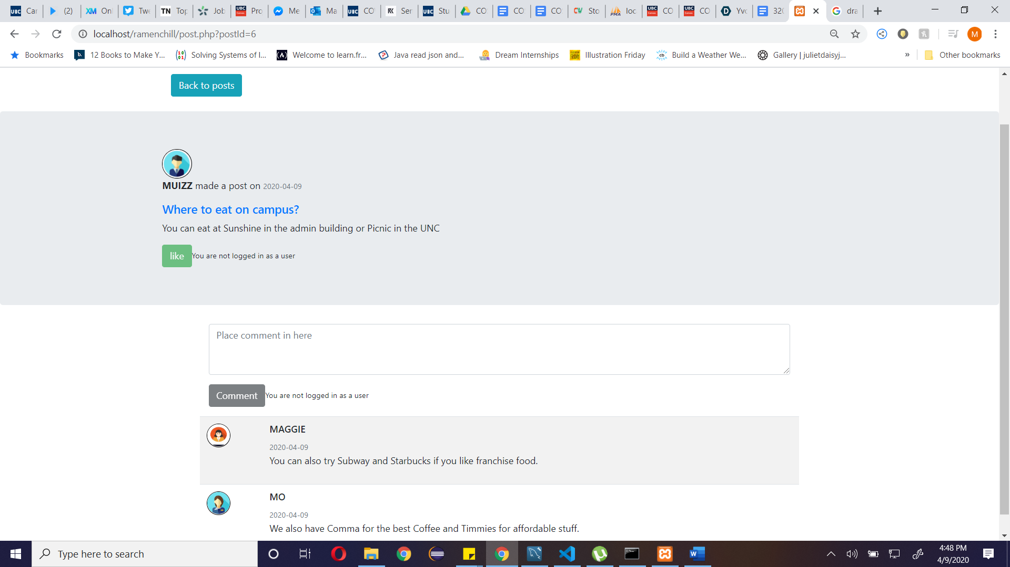

FEATURES (before user log on):

* Search bar: both registered and unregistered users can search for forum posts.
* Post section: contains post details i.e. username, date, profile picture etc.
* Comments section: disabled for unregistered users.
* Menu: unregistered users have access to the about page, login and signup pages.
* Like button: disabled for unregistered users.
* Comments list: list of comments made. Accessible for reading by both registered and unregistered users.

FEATURES (after user log on):

* Menu: registered users have access to the about page, profile page and the logout option
* Comments section: contains form with a required field which a user can use to make a comment on a post upon submission.
* Like button: users can like a post. Button changes to unlike if the user has already liked the post.

ADMINISTRATOR PAGE:

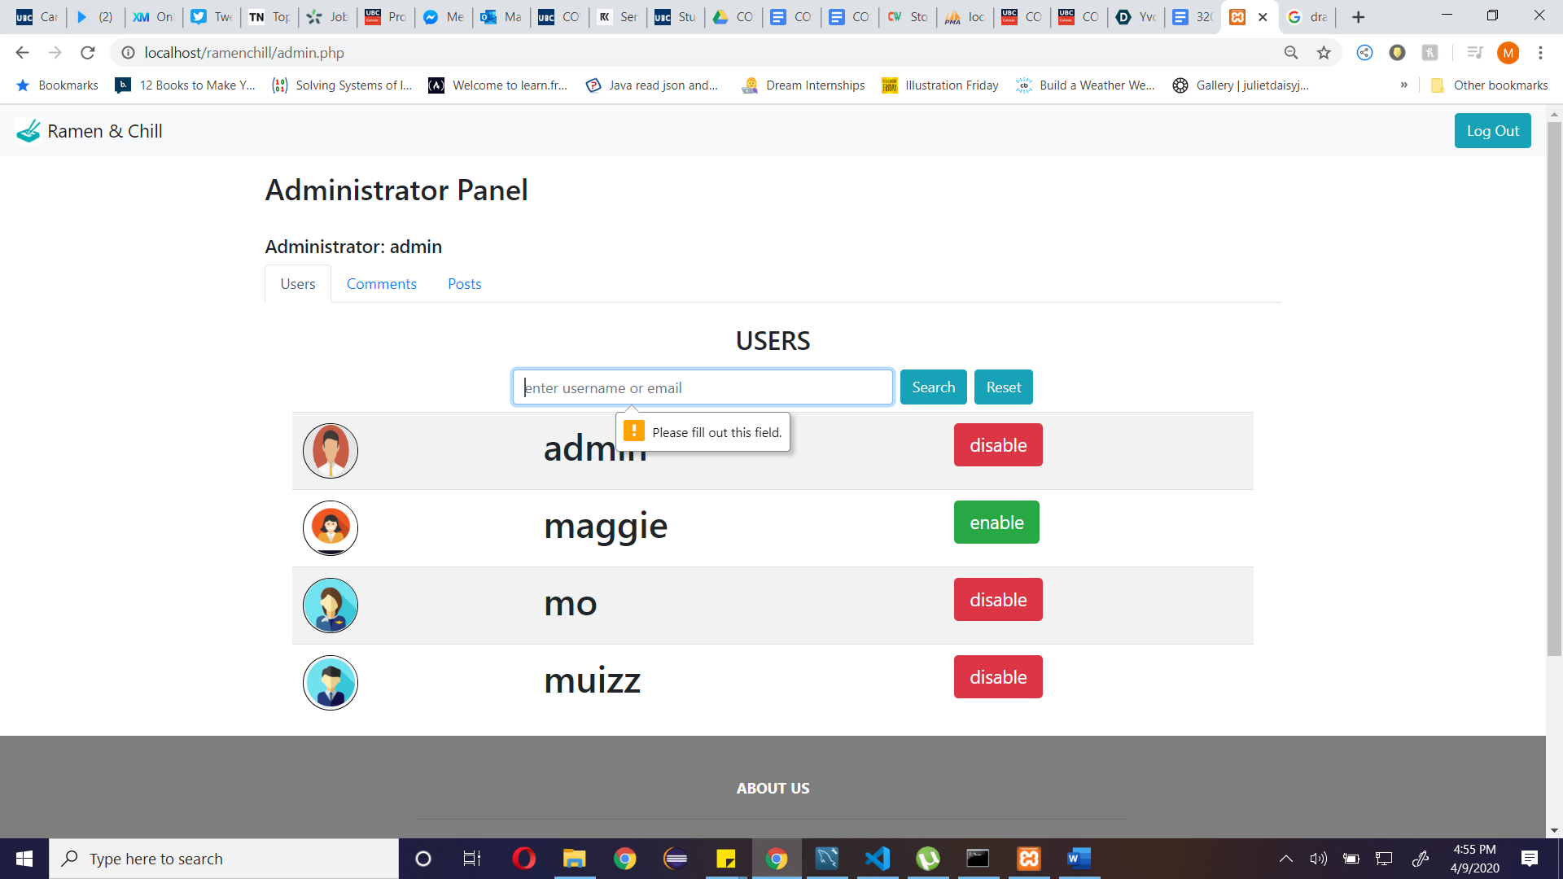

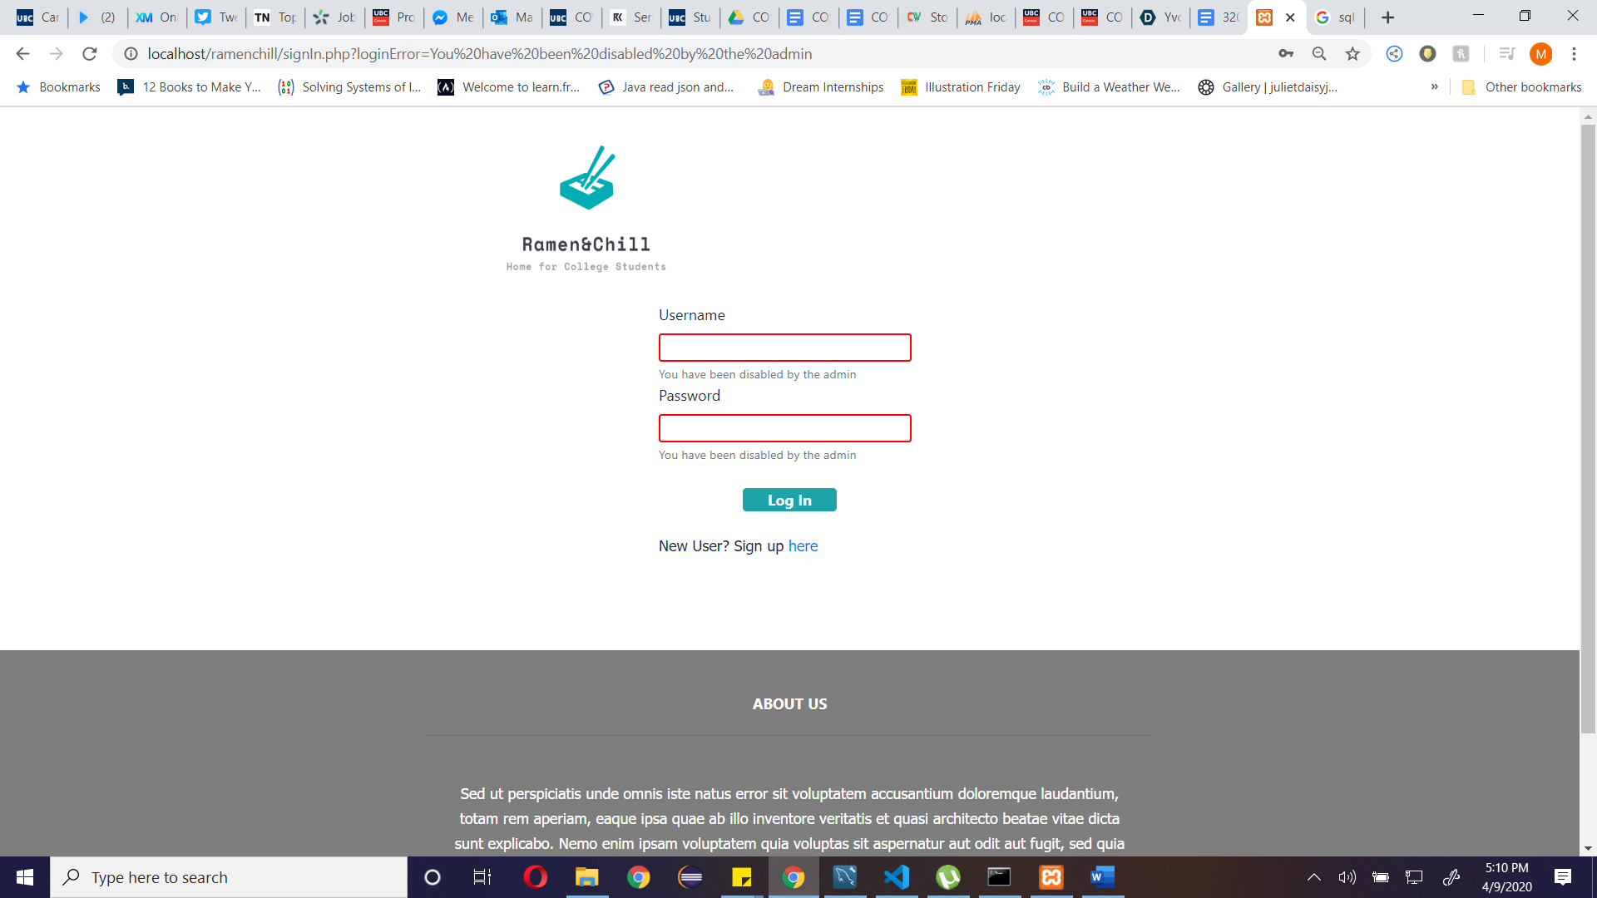

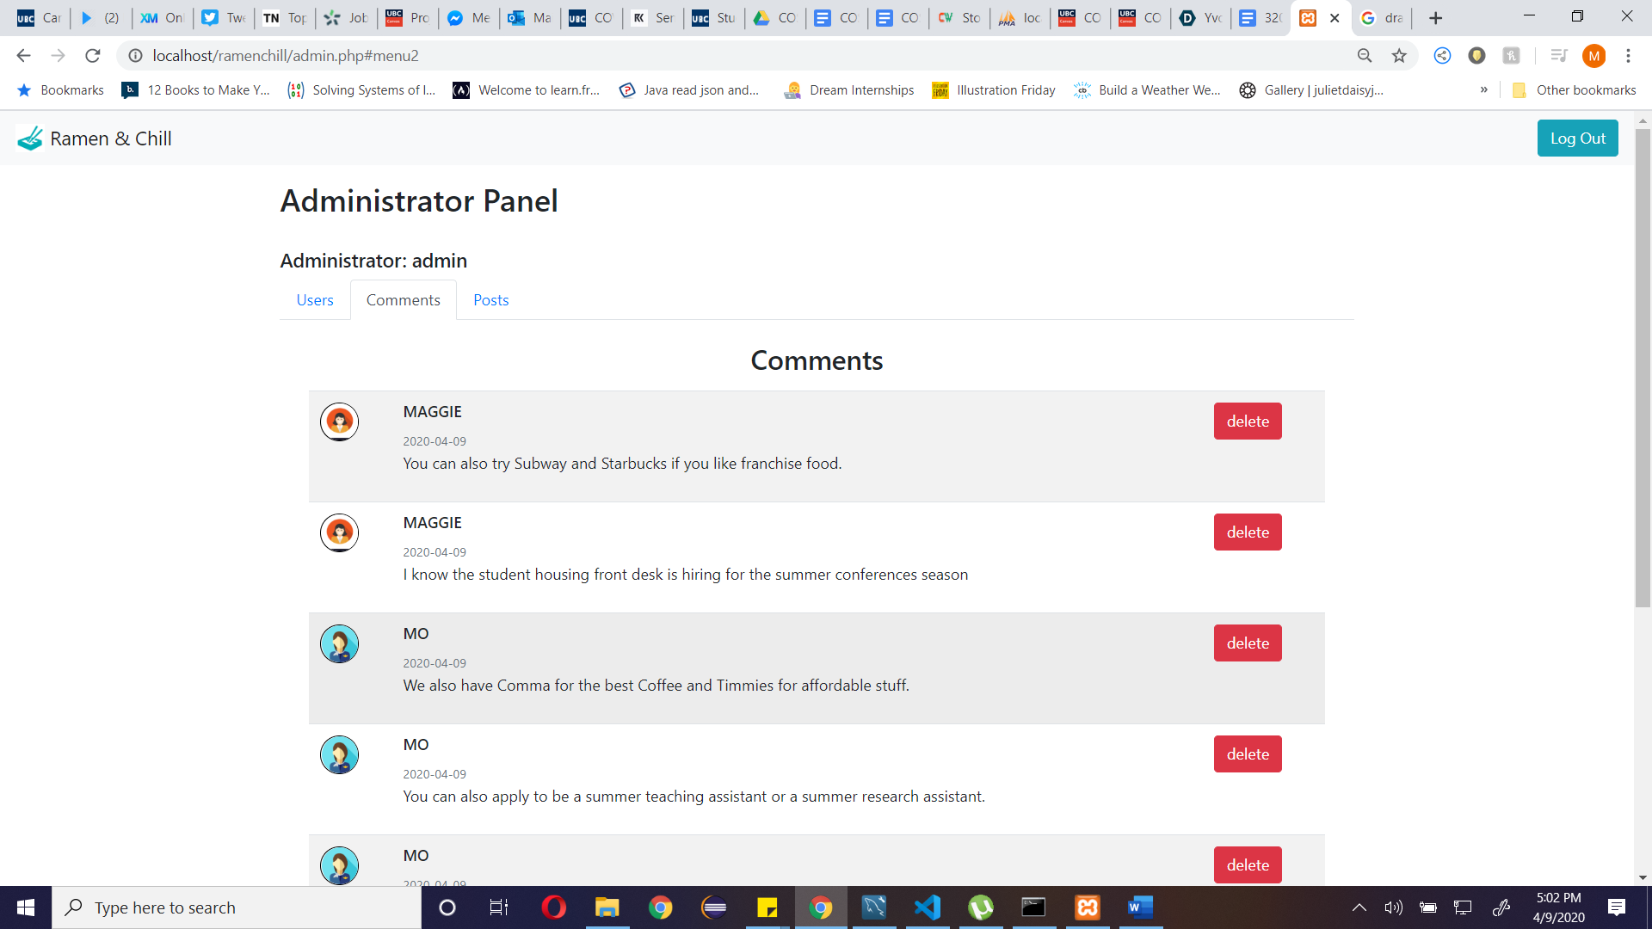

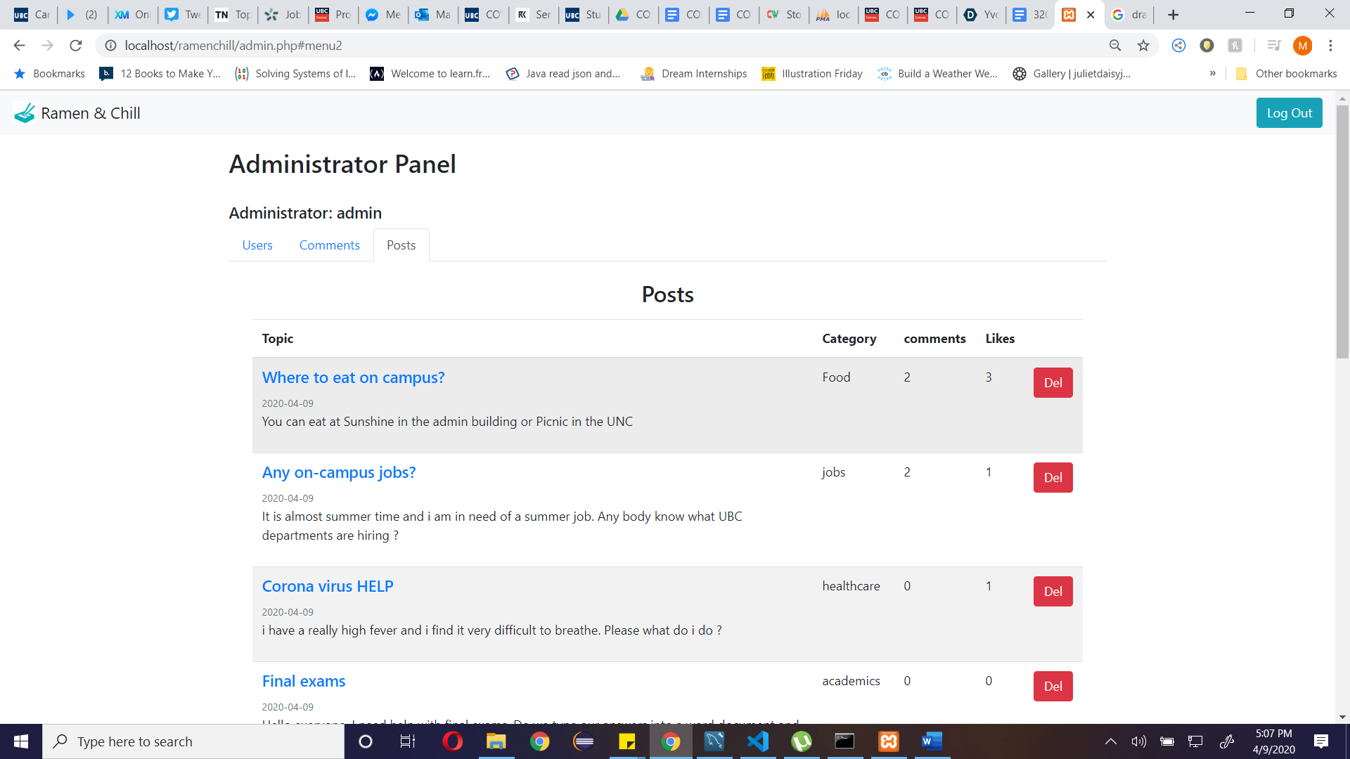

FEATURES (only accessible by users designated to be administrators):

* Navbar: on click of logo returns user to home page and logout button.
* Users section: contains a list of users and enable/disable button. Administrators can enable and disable users from log on to the platform. Also contains search bar where administrators can search for users by their names and email addresses.
* Comments section: contains a list of all the comments (and their details) on the platform and a delete button. Administrators can delete any comment as they wish.
* Post section: contains a list of all the posts (and their details) on the platform and a delete button. Administrators can delete any posts on the platform.

ABOUT US PAGE:

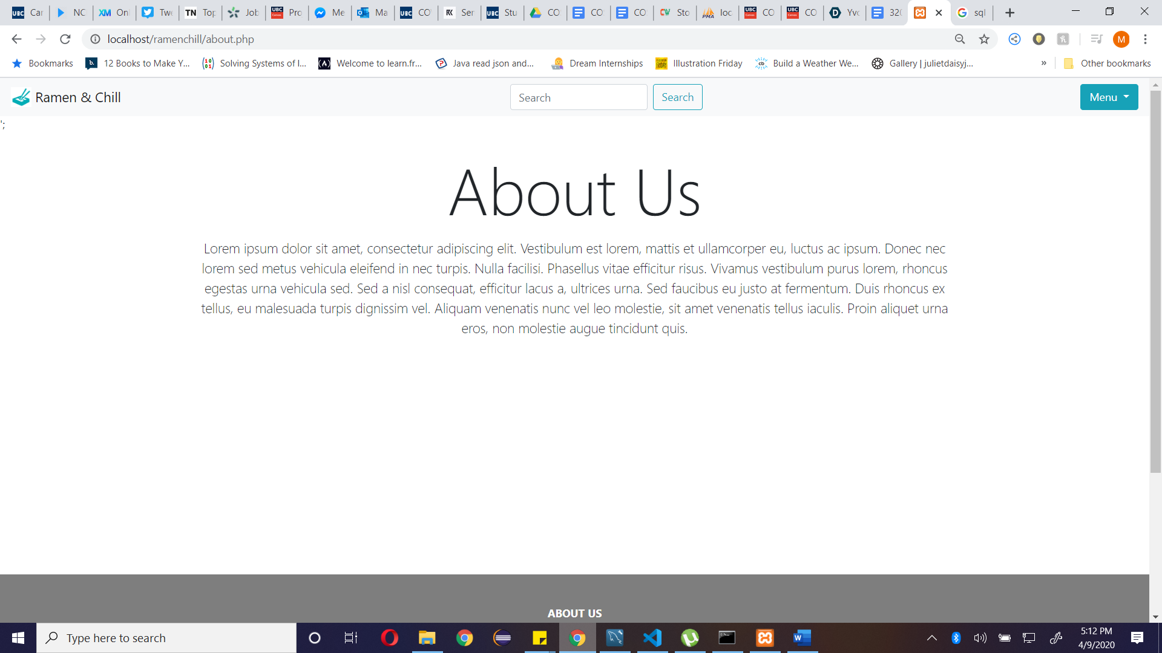

Features:

* Navbar: contains search section, logo and the menu buttons.
* About Us section: contains information about the company Ramen and Chill
* Footer: page footer containing company details, copyright and company social media details.

SQL:

-- phpMyAdmin SQL Dump

-- version 4.9.0.1

-- https://www.phpmyadmin.net/

--

-- Host: 127.0.0.1

-- Generation Time: Apr 10, 2020 at 12:42 AM

-- Server version: 10.3.16-MariaDB

-- PHP Version: 7.1.30

SET SQL_MODE = "NO_AUTO_VALUE_ON_ZERO";

SET AUTOCOMMIT = 0;

START TRANSACTION;

SET time_zone = "+00:00";

/*!40101 SET @OLD_CHARACTER_SET_CLIENT=@@CHARACTER_SET_CLIENT */;

/*!40101 SET @OLD_CHARACTER_SET_RESULTS=@@CHARACTER_SET_RESULTS */;

/*!40101 SET @OLD_COLLATION_CONNECTION=@@COLLATION_CONNECTION */;

/*!40101 SET NAMES utf8mb4 */;

--

-- Database: `ramen_chill`

--

CREATE DATABASE IF NOT EXISTS `ramen_chill` DEFAULT CHARACTER SET latin1 COLLATE latin1_swedish_ci;

USE `ramen_chill`;

-- --------------------------------------------------------

--

-- Table structure for table `admin`

--

CREATE TABLE `admin` (

`username` varchar(20) NOT NULL

) ENGINE=InnoDB DEFAULT CHARSET=latin1;

--

-- Dumping data for table `admin`

--

INSERT INTO `admin` (`username`) VALUES

('admin');

-- --------------------------------------------------------

--

-- Table structure for table `category`

--

CREATE TABLE `category` (

`postId` int(11) NOT NULL,

`category` varchar(50) NOT NULL

) ENGINE=InnoDB DEFAULT CHARSET=latin1;

--

-- Dumping data for table `category`

--

INSERT INTO `category` (`postId`, `category`) VALUES

(6, 'Food'),

(7, 'jobs'),

(8, 'healthcare'),

(9, 'academics'),

(10, 'finances'),

(11, 'studentLife'),

(12, 'healthcare'),

(13, 'healthcare'),

(14, 'general');

-- --------------------------------------------------------

--

-- Table structure for table `comment`

--

CREATE TABLE `comment` (

`commentId` int(11) NOT NULL,

`content` varchar(100) NOT NULL,

`created` date NOT NULL DEFAULT current_timestamp(),

`postId` int(11) NOT NULL,

`username` varchar(20) NOT NULL

) ENGINE=InnoDB DEFAULT CHARSET=latin1;

--

-- Dumping data for table `comment`

--

INSERT INTO `comment` (`commentId`, `content`, `created`, `postId`, `username`) VALUES

(15, 'You can also try Subway and Starbucks if you like franchise food.', '2020-04-09', 6, 'maggie'),

(16, 'I know the student housing front desk is hiring for the summer conferences season', '2020-04-09', 7, 'maggie'),

(17, 'Make sure you start self isolating!', '2020-04-09', 8, 'maggie'),

(18, 'We also have Comma for the best Coffee and Timmies for affordable stuff.', '2020-04-09', 6, 'mo'),

(19, 'You can also apply to be a summer teaching assistant or a summer research assistant.', '2020-04-09', 7, 'mo'),

(20, 'There is a form on their Instagram page that you can fill up.', '2020-04-09', 10, 'mo');

-- --------------------------------------------------------

--

-- Table structure for table `isliked`

--

CREATE TABLE `isliked` (

`username` varchar(20) NOT NULL,

`postId` int(11) NOT NULL

) ENGINE=InnoDB DEFAULT CHARSET=latin1;

--

-- Dumping data for table `isliked`

--

INSERT INTO `isliked` (`username`, `postId`) VALUES

('maggie', 6),

('maggie', 8),

('mo', 6),

('mo', 7),

('mo', 10);

-- --------------------------------------------------------

--

-- Table structure for table `post`

--

CREATE TABLE `post` (

`postId` int(11) NOT NULL,

`content` varchar(500) NOT NULL,

`created` date NOT NULL DEFAULT current_timestamp(),

`category` varchar(50) NOT NULL,

`title` varchar(100) NOT NULL,

`username` varchar(20) NOT NULL

) ENGINE=InnoDB DEFAULT CHARSET=latin1;

--

-- Dumping data for table `post`

--

INSERT INTO `post` (`postId`, `content`, `created`, `category`, `title`, `username`) VALUES

(6, 'You can eat at Sunshine in the admin building or Picnic in the UNC', '2020-04-09', 'Food', 'Where to eat on campus?', 'muizz'),

(7, 'It is almost summer time and i am in need of a summer job. Any body know what UBC departments are hiring ?', '2020-04-09', 'jobs', 'Any on-campus jobs?', 'muizz'),

(8, 'i have a really high fever and i find it very difficult to breathe. Please what do i do ?', '2020-04-09', 'healthcare', 'Corona virus HELP', 'muizz'),

(9, 'Hello everyone. I need help with final exams. Do we type our answers into a word document and submit or do we write it by hand, scan then submit?', '2020-04-09', 'academics', 'Final exams', 'maggie'),

(10, 'Is it true that the SUO is giving out relief funds? If so, how do i access them?', '2020-04-09', 'finances', 'COVID_19 relief funds', 'maggie'),

(11, 'Does anyone know who the headline act for RECESS is ? Have the released the line up ? what a ticket prices ?', '2020-04-09', 'studentLife', 'RECESS 2019', 'maggie'),

(12, 'Can someone suggest some home workout for me plus anyone know when the gym is gonna be open?', '2020-04-09', 'healthcare', 'Summer body?', 'mo'),

(13, 'Did you guys here about the Indian restaurant? I heard their food gave a lot of students food poisoning. Can anybody confirm this?', '2020-04-09', 'healthcare', 'Food poisoning in the UNC', 'mo'),

(14, 'Has anyone booked the Nonis field for the above time? If not, how can i do it?', '2020-04-09', 'general', 'Soccer at 5pm on Fridays', 'mo');

-- --------------------------------------------------------

--

-- Table structure for table `user`

--

CREATE TABLE `user` (

`username` varchar(20) NOT NULL,

`password` varchar(255) NOT NULL,

`email` varchar(50) NOT NULL,

`Bio` varchar(100) NOT NULL,

`image` longtext NOT NULL,

`disabled` tinyint(1) NOT NULL DEFAULT 0

) ENGINE=InnoDB DEFAULT CHARSET=latin1;

--

-- Dumping data for table `user`

--

INSERT INTO `user` (`username`, `password`, `email`, `Bio`, `image`, `disabled`) VALUES

('admin', '$2y$10$lmYsXzy3.0dR3OBvgYpJjeOANb7tp4UPWgG.3NMwHBDLa2LZf9rSq', 'abdelmuizz.yusuf@hotmail.com', 'I am the admin', 'user1.jpg', 0),

('maggie', '$2y$10$6Gvz/QjUgalIOWJhct2mge2OcdPZwxXKPIV8QwU4o.1NbwvbmWMgK', 'margreta@gmail.com', 'The coolest girl in the world', 'user2.jpg', 0),

('mo', '$2y$10$SfP3/Thcis0h6//sqS6/ue8eAH3di9CbTe57ZLNrxFEaXkzNRoGKW', 'mohamed@gmail.com', 'I am your professor', 'user 4.png', 0),

('muizz', '$2y$10$pAtEym2mXUokKXEBHm60NuCTbFZZkuUjjvygTtz1EuxnFxQ6kDJLS', 'abdelmuizz.yusuf@hotmail.com', 'I am one of the creators of this app', 'user3.png', 0);

--

-- Indexes for dumped tables

--

--

-- Indexes for table `admin`

--

ALTER TABLE `admin`

ADD PRIMARY KEY (`username`);

--

-- Indexes for table `category`

--

ALTER TABLE `category`

ADD PRIMARY KEY (`postId`,`category`);

--

-- Indexes for table `comment`

--

ALTER TABLE `comment`

ADD PRIMARY KEY (`commentId`),

ADD KEY `username` (`username`),

ADD KEY `comment_ibfk_1` (`postId`);

--

-- Indexes for table `isliked`

--

ALTER TABLE `isliked`

ADD PRIMARY KEY (`username`,`postId`),

ADD KEY `postId` (`postId`);

--

-- Indexes for table `post`

--

ALTER TABLE `post`

ADD PRIMARY KEY (`postId`),

ADD KEY `username` (`username`);

--

-- Indexes for table `user`

--

ALTER TABLE `user`

ADD PRIMARY KEY (`username`);

--

-- AUTO_INCREMENT for dumped tables

--

--

-- AUTO_INCREMENT for table `comment`

--

ALTER TABLE `comment`

MODIFY `commentId` int(11) NOT NULL AUTO_INCREMENT, AUTO_INCREMENT=21;

--

-- AUTO_INCREMENT for table `post`

--

ALTER TABLE `post`

MODIFY `postId` int(11) NOT NULL AUTO_INCREMENT, AUTO_INCREMENT=15;

--

-- Constraints for dumped tables

--

--

-- Constraints for table `admin`

--

ALTER TABLE `admin`

ADD CONSTRAINT `admin_ibfk_1` FOREIGN KEY (`username`) REFERENCES `user` (`username`) ON DELETE CASCADE ON UPDATE CASCADE;

--

-- Constraints for table `category`

--

ALTER TABLE `category`

ADD CONSTRAINT `category_ibfk_1` FOREIGN KEY (`postId`) REFERENCES `post` (`postId`) ON DELETE CASCADE ON UPDATE CASCADE;

--

-- Constraints for table `comment`

--

ALTER TABLE `comment`

ADD CONSTRAINT `comment_ibfk_1` FOREIGN KEY (`postId`) REFERENCES `post` (`postId`) ON DELETE CASCADE ON UPDATE CASCADE,

ADD CONSTRAINT `comment_ibfk_2` FOREIGN KEY (`username`) REFERENCES `user` (`username`) ON DELETE CASCADE ON UPDATE CASCADE;

--

-- Constraints for table `isliked`

--

ALTER TABLE `isliked`

ADD CONSTRAINT `isliked_ibfk_1` FOREIGN KEY (`username`) REFERENCES `user` (`username`) ON DELETE CASCADE ON UPDATE CASCADE,

ADD CONSTRAINT `isliked_ibfk_2` FOREIGN KEY (`postId`) REFERENCES `post` (`postId`) ON DELETE CASCADE ON UPDATE CASCADE;

--

-- Constraints for table `post`

--

ALTER TABLE `post`

ADD CONSTRAINT `post_ibfk_1` FOREIGN KEY (`username`) REFERENCES `user` (`username`) ON DELETE CASCADE ON UPDATE CASCADE;

COMMIT;

/*!40101 SET CHARACTER_SET_CLIENT=@OLD_CHARACTER_SET_CLIENT */;

/*!40101 SET CHARACTER_SET_RESULTS=@OLD_CHARACTER_SET_RESULTS */;

/*!40101 SET COLLATION_CONNECTION=@OLD_COLLATION_CONNECTION */;